COMPETITIVE PROGRAMMING
LAB-1
2303A52434
V. Sathvika
Batch-38

Assignment 1: Maximum Non-Overlapping Meetings (Greedy)
Problem Statement
You are given N meetings. Each meeting has a start time Si and an end time Ei. You want
to attend the maximum number of meetings. You can attend meeting j after meeting i
only if the start time of meeting j is strictly greater than the end time of meeting i (Sj >
Ei). For each test case, output the maximum number of meetings that can be attended.
Input Format
The first line contains an integer T, the number of test cases.For each test case:
- The first line contains an integer N.
- The next N lines each contain two integers Si and Ei.
Output Format: For each test case, print a single integer: the maximum number of
meetings that can be attended.
Constraints
- 1 ≤ T ≤ 20
- 1 ≤ N ≤ 200000 (sum of N over all test cases ≤ 200000)
- 0 ≤ Si < Ei ≤ 10^9
Sample Input
1
3
1 3
2 4
3 5
Expected Output 2

CODE:
n = int(input())
start = []
end = []
for i in range(n):
s, e = map(int, input().split())
start.append(s)
end.append(e)
for i in range(n):
for j in range (i + 1, n):
if end[i] > end[j]:
end[i], end[j] = end[j], end[i]
start[i], start[j] = start[j], start[i]
count = 1
last_ end = end [0]
for i in range (1, n):
if start[i] >= last_ end:
count += 1
last_end = end[i]
print(count)
OUTPUT:
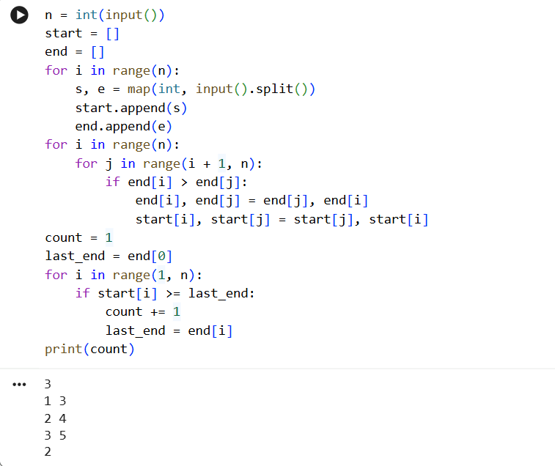
Assignment 2: Shelf Product Lookup (Divide and Conquer)
Problem Statement
A supermarket maintains a sorted list of product IDs. For each query ID X, determine
how many times X appears in the list. You must solve using binary-search style divide
and conquer (find first occurrence and last occurrence).
Input FormatThe first line contains integer T. For each test case:
- First line: N Q
- Second line: N integers (sorted product IDs)
- Next Q lines: integer X (query ID)
Output FormatFor each query, print the count of X on a new line.
Constraints
- 1 ≤ T ≤ 20
- 1 ≤ N ≤ 200000 (sum of N over all test cases ≤ 200000)
- 1 ≤ Q ≤ 200000 (sum of Q over all test cases ≤ 200000)
- Product IDs fit in 32-bit signed integer
Sample Input
1
8 3
101 101 102 102 102 105 110 110 101 102 999
Expected Output
230
CODE:
t = int(input())

for _ in range(t):
n, q = map(int, input().split())
arr = list(map(int, input().split()))
queries = list(map(int, input().split()))

for x in queries:
low = 0
high = n - 1
first = -1

while low <= high:
mid = (low + high) // 2
if arr[mid] == x:
first = mid
high = mid - 1
elif arr[mid] < x:
low = mid + 1
else:
high = mid - 1

if first == -1:
print(0, end="")
continue
low = 0
high = n - 1
last = -1

while low <= high:
mid = (low + high) // 2
if arr[mid] == x:
last = mid
low = mid + 1
elif arr[mid] < x:
low = mid + 1
else:
high = mid - 1
print(last - first + 1, end="")
OUTPUT
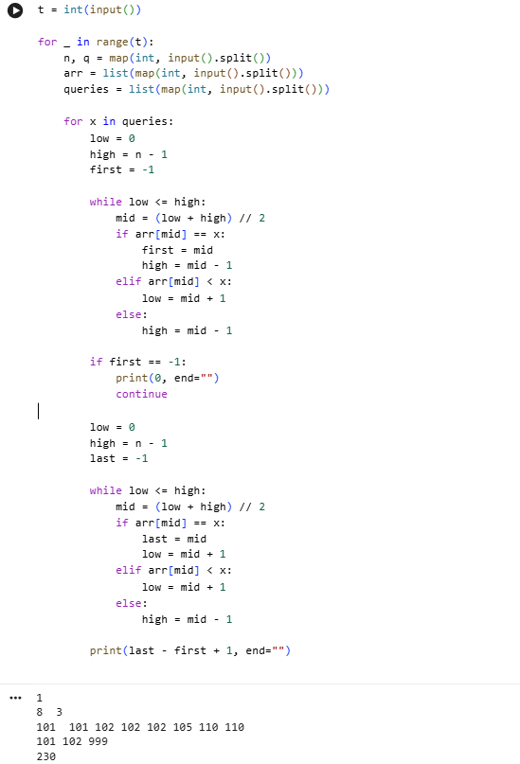
Assignment 3: Fractional Knapsack (Greedy)
Problem Statement
You are given N items. Item i has value Vi and weight Wi. You have a knapsack of
capacity W. You may take any fraction of an item (including the whole item). Your goal
is to maximize the total value in the knapsack without exceeding the capacity. For each
test case, output the maximum total value achievable. The result must be printed with
exactly 6 digits after the decimal point.
Input Format
The first line contains an integer T, the number of test cases. For each test case:
- The first line contains two integers N and W.
- The next N lines each contain two integers Vi and Wi.
Output Format
For each test case, print one number: the maximum value, formatted to 6 decimal places.
Constraints
- 1 ≤ T ≤ 20
- 1 ≤ N ≤ 200000 (sum of N over all test cases ≤ 200000)
- 1 ≤ Vi, Wi, W ≤ 10^9
Sample Input
1
3 50
60 10
100 20
120 30
CODE:
t = int(input().strip())

for _ in range(t):
n, W = map(int, input().split())
items = []

for _ in range(n):
v, w = map(int, input().split())
items.append((v / w, v, w))

# sort by value per weight
items.sort(reverse=True)

total = 0.0
capacity = W

for ratio, value, weight in items:
if capacity == 0:
break
if weight <= capacity:
total += value
capacity -= weight
else:
total += ratio * capacity
break

print(f"{total:.6f}")

OUTPUT:
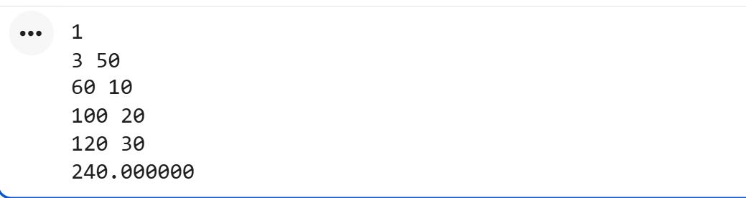

Assignment 4: Package Priority Sorting (Divide and Conquer)
Problem Statement
A warehouse records package priority scores as integers. To dispatch efficiently, you
must sort the scores in non-decreasing order using merge sort (divide and conquer). For
each test case, output the sorted list.
Input Format
The first line contains integer T.For each test case:
- First line: N
- Second line: N integers (priority scores)
Output Format
For each test case, print the sorted array in one line (space-separated).
Constraints
- 1 ≤ T ≤ 20
- 1 ≤ N ≤ 200000 (sum of N over all test cases ≤ 200000)
- -10^9 ≤ Ai ≤ 10^9
Sample Input
1
7
4 1 6 2 5 3 2
Expected Output
1 2 2 3 4 5 6
CODE:
def merge_sort(arr):
if len(arr) <= 1:
return arr

mid = len(arr) // 2
left = merge_sort(arr[:mid])
right = merge_sort(arr[mid:])

result = []
i = j = 0

while i < len(left) and j < len(right):
if left[i] <= right[j]:
result.append(left[i])
i += 1
else:
result.append(right[j])
j += 1

result.extend(left[i:])
result.extend(right[j:])
return result

T = int(input())

for _ in range(T):
N = int(input())
arr = list(map(int, input().split()))

sorted_arr = merge_sort(arr)
print(*sorted_arr)
OUTPUT:
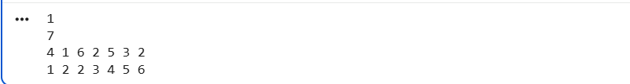

Assignment 5: Job Sequencing with Deadlines (Greedy)
Problem Statement
You are given N jobs. Each job takes exactly 1 unit of time. Job i has a deadline Di and a
profit Pi. If a job is completed on or before its deadline, its profit is earned; otherwise, it
cannot be counted. You can perform at most one job at a time. Your task is to choose and
schedule jobs to maximize total profit. For each test case, output: (1) the number of jobs
completed (2) the maximum total profit.
Input Format
The first line contains an integer T, the number of test cases.For each test case:
- The first line contains an integer N.
- The next N lines each contain two integers Di and Pi.
Output Format
For each test case, print two integers:jobs_done total_profit
Constraints
- 1 ≤ T ≤ 20
- 1 ≤ N ≤ 200000 (sum of N over all test cases ≤ 200000)
1 ≤ Di ≤ 100000- 1 ≤ Pi ≤ 10^9
Sample Input
1
5
2 100
1 19
2 27
1 25
3 15
Expected Output
3 142
CODE:
T = int(input())

for _ in range(T):
N = int(input())
jobs = []

for _ in range(N):
d, p = map(int, input().split())
jobs.append((p, d)) # (profit, deadline)

jobs.sort(reverse=True)

max_deadline = max(d for _, d in jobs)
slots = [False] * (max_deadline + 1)

jobs_done = 0
total_profit = 0

for profit, deadline in jobs:
for t in range(deadline, 0, -1):
if not slots[t]:
slots[t] = True
jobs_done += 1
total_profit += profit
break

print(jobs_done, total_profit)
OUTPUT:
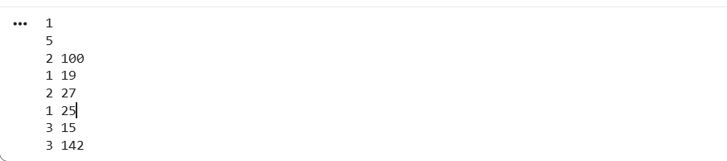
Assignment 6: Maximum Profit Streak (Divide and Conquer)
Problem Statement
A company tracks daily profit changes as an array A (values can be negative). A “profit
streak” is any non-empty contiguous subarray. Find the maximum possible sum of a
profit streak using a divide-and-conquer approach (split into left, right, and crossing
subproblems).
Input Format
The first line contains integer T.For each test case:
- First line: N
- Second line: N integers A1..AN
Output Format
For each test case, print one integer: maximum subarray sum.
Constraints
- 1 ≤ T ≤ 20
- 1 ≤ N ≤ 200000 (sum of N over all test cases ≤ 200000)
- -10^9 ≤ Ai ≤ 10^9
Sample Input
1
9
-2 1 -3 4 -1 2 1 -5 4
Expected Output
6
CODE:
def max_crossing_sum(arr, left, mid, right):
left_sum = float('-inf')

total = 0
for i in range(mid, left - 1, -1):
total += arr[i]
left_sum = max(left_sum, total)

right_sum = float('-inf')
total = 0
for i in range(mid + 1, right + 1):
total += arr[i]
right_sum = max(right_sum, total)

return left_sum + right_sum

def max_subarray(arr, left, right):
if left == right:
return arr[left]

mid = (left + right) // 2

return max(
max_subarray(arr, left, mid),
max_subarray(arr, mid + 1, right),
max_crossing_sum(arr, left, mid, right)
)

T = int(input())

for _ in range(T):
N = int(input())
arr = list(map(int, input().split()))

print(max_subarray(arr, 0, N - 1))

OUTPUT:
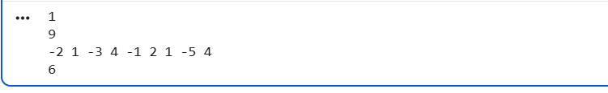

Assignment 7: Minimum Platforms Required (Greedy)
Problem Statement
A railway station has arrival and departure times for N trains. A platform is required from
a train’s arrival until its departure. If one train arrives at the exact time another departs,
the same platform can be reused. Determine the minimum number of platforms needed so
that no train waits.
Input Format
The first line contains integer T.For each test case:- First line: N
- Second line: N integers (arrival times)
- Third line: N integers (departure times)
Output Format
For each test case, print one integer: minimum platforms required.
Constraints
- 1 ≤ T ≤ 20
- 1 ≤ N ≤ 200000 (sum of N over all test cases ≤ 200000)
- 0 ≤ time ≤ 10^9
Sample Input
1
6
900 940 950 1100 1500 1800
910 1200 1120 1130 1900 2000
Expected Output
3
CODE:
T = int(input())

for _ in range(T):
N = int(input())

arrival = list(map(int, input().split()))
departure = list(map(int, input().split()))

# Sort arrival and departure times
arrival.sort()
departure.sort()

platforms = 0
max_platforms = 0
i = j = 0

# Use two pointers
while i < N and j < N:
if arrival[i] < departure[j]:
platforms += 1
max_platforms = max(max_platforms, platforms)
i += 1
else:
platforms -= 1
j += 1

print(max_platforms)
OUTPUT:

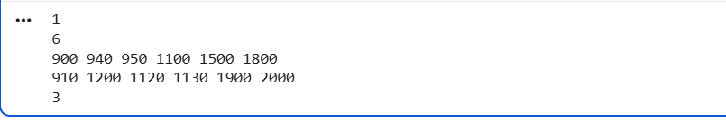

Assignment 8: Count Inversions (Divide and Conquer)
Problem Statement
Given an array A of size N, an inversion is a pair of indices (i, j) such that i < j and A[i] >
A[j]. Your task is to count the total number of inversions in the array. This must be
solved efficiently for large N (a naive O(N^2) approach will not pass).
Input Format
The first line contains an integer T, the number of test cases.For each test case:
- The first line contains an integer N.
- The second line contains N integers representing the array.
Output Format
For each test case, print a single integer: the inversion count.
Constraints
- 1 ≤ T ≤ 20
- 1 ≤ N ≤ 200000 (sum of N over all test cases ≤ 200000)
-10^9 ≤ A[i] ≤ 10^9
Sample Input
2
5
2 4 1 3 5
4
4 3 2 1
Expected Output
3
6
CODE:
def merge_and_count(arr, temp, left, mid, right):
i = left
j = mid + 1
k = left
inv_count = 0

while i <= mid and j <= right:
if arr[i] <= arr[j]:
temp[k] = arr[i]
i += 1
else:
temp[k] = arr[j]
inv_count += (mid - i + 1)
j += 1
k += 1

while i <= mid:
temp[k] = arr[i]
i += 1
k += 1

while j <= right:
temp[k] = arr[j]
j += 1
k += 1

for i in range(left, right + 1):
arr[i] = temp[i]

return inv_count

def merge_sort_and_count(arr, temp, left, right):
inv_count = 0
if left < right:
mid = (left + right) // 2

inv_count += merge_sort_and_count(arr, temp, left, mid)
inv_count += merge_sort_and_count(arr, temp, mid + 1, right)
inv_count += merge_and_count(arr, temp, left, mid, right)

return inv_count

T = int(input())

for _ in range(T):
N = int(input())
arr = list(map(int, input().split()))
temp = [0] * N

print(merge_sort_and_count(arr, temp, 0, N - 1))
OUTPUT:
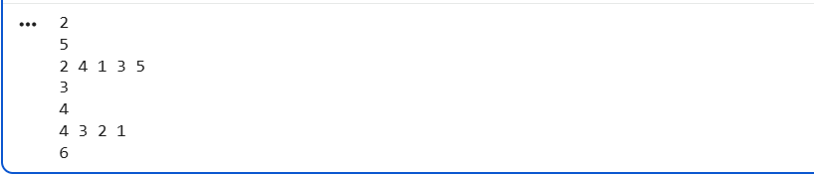
Assignment 9: Minimum Cost to Connect Cables (Greedy)
Problem Statement
A data center needs to connect N network cables into one cable. Connecting two cables
of lengths a and b costs (a + b). The new combined cable has length (a + b). This
combined cable can again be connected with others. Find the minimum total cost to
connect all cables into one.
Input FormatThe first line contains integer T.For each test case:
- First line: N
- Second line: N integers (cable lengths)
Output Format
For each test case, print one integer: minimum total cost.
Constraints
- 1 ≤ T ≤ 20
- 1 ≤ N ≤ 200000 (sum of N over all test cases ≤ 200000)
- 1 ≤ length ≤ 10^9
Sample Input
1
4
4 3 2 6
Expected Output
29
CODE:
import heapq

T = int(input())

for _ in range(T):
N = int(input())
cables = list(map(int, input().split()))

# Create a min-heap
heapq.heapify(cables)

total_cost = 0

# Keep connecting until one cable remains
while len(cables) > 1:
a = heapq.heappop(cables)
b = heapq.heappop(cables)

cost = a + b
total_cost += cost

heapq.heappush(cables, cost)

print(total_cost)

OUTPUT:
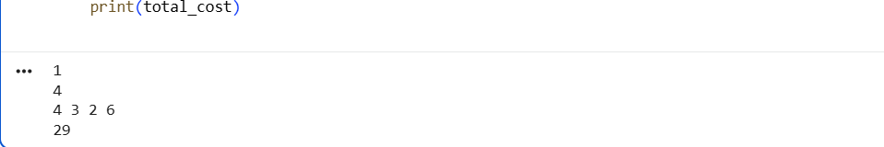
Assignment 10: Kth Smallest Element (Quickselect Divide and Conquer)
Problem Statement
You are given an array of N integers and an integer K (1-indexed). You must find the Kth
smallest element in the array. For each test case, output the Kth smallest element.
Input Format
The first line contains an integer T, the number of test cases.For each test case:
- The first line contains two integers N and K.
- The second line contains N integers.
Output Format
For each test case, print a single integer: the Kth smallest element.
Constraints
- 1 ≤ T ≤ 20
- 1 ≤ N ≤ 200000 (sum of N over all test cases ≤ 200000)
- 1 ≤ K ≤ N
- -10^9 ≤ A[i] ≤ 10^9
Sample Input
2
6 3
7 10 4 3 20 15
7 4
12 3 5 7 19 0 2
Expected Output
75
CODE:
T = int(input())
result = ""

for _ in range(T):
N, K = map(int, input().split())
arr = list(map(int, input().split()))

arr.sort()
result += str(arr[K - 1]) # concatenate result

print(result)
OUTPUT:
